HIVE  
<https://www.sparkcodehub.com/hive/hive-tutorial>

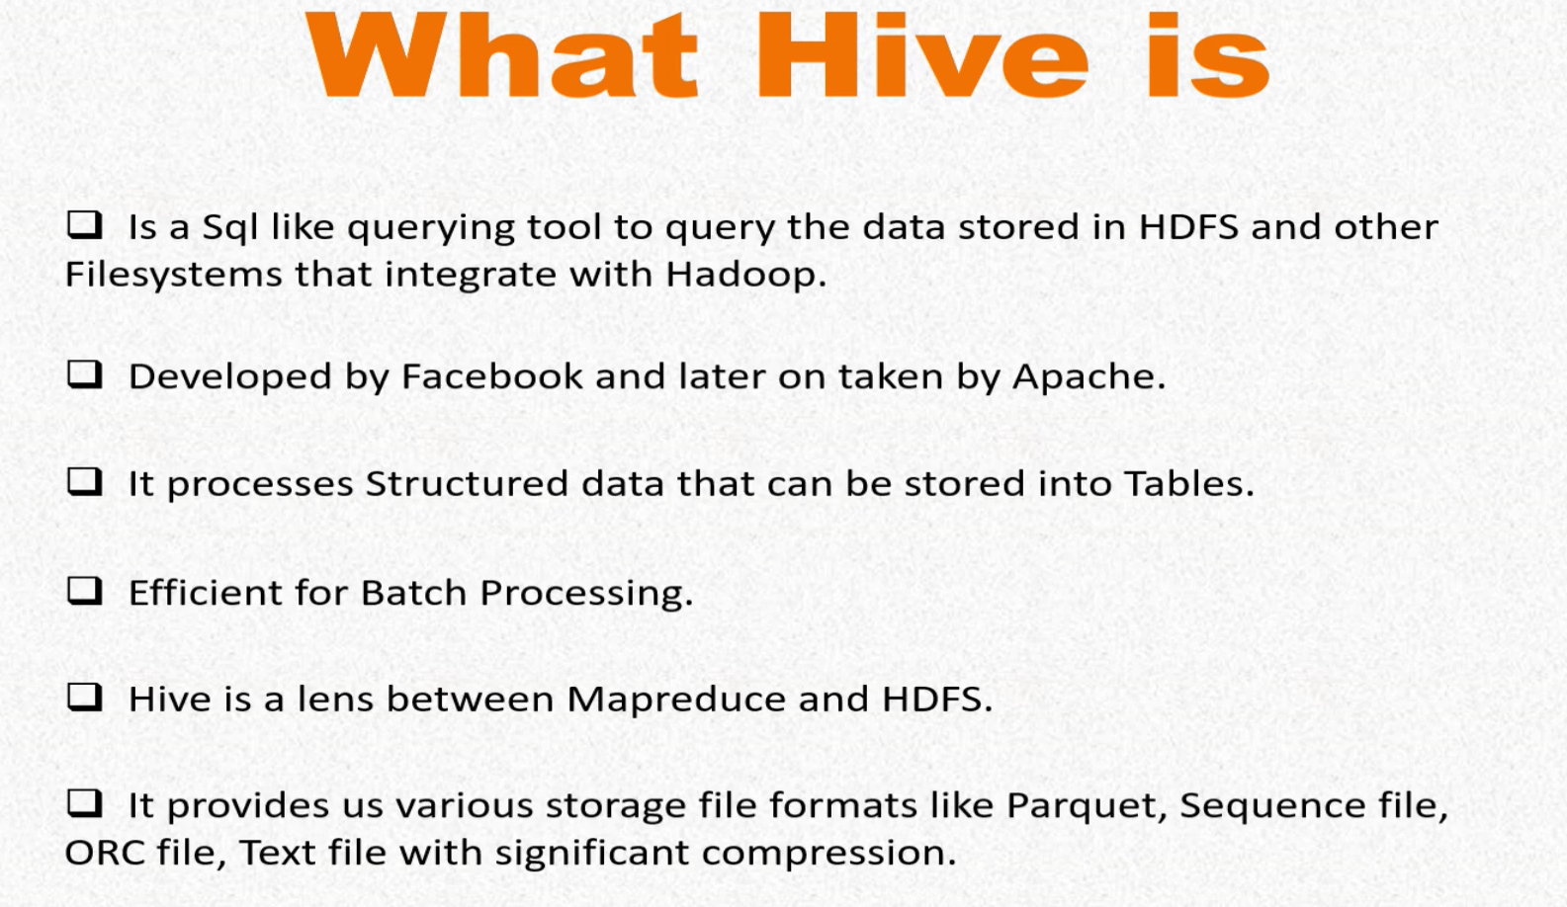

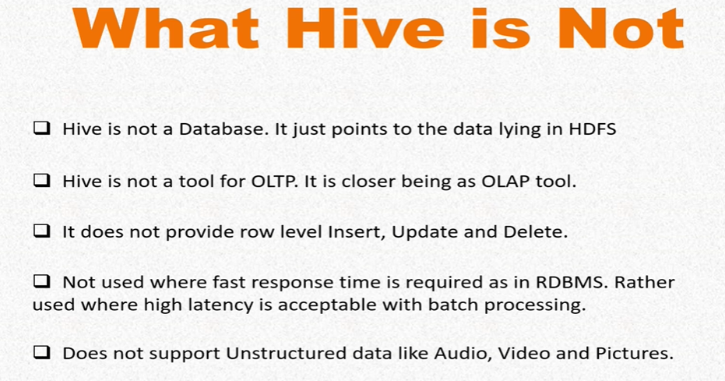

The only reason for which Hive was developed was, to reduce the complexity of MapReduce programming. You might know, that simplest of MapReduce programs will consist of hundreds of lines of code.

The task of converting the query into MapReduce programs is taken by Hive

compiler, and we need not to worry about this conversion.

**Key differences in Hive and SQL.**

Hive is not exactly same as SQL.

First is, that hive is not a database as it does not hold physical data. Our actual data remains stored in HDFS files only and not in Hive. Hive is just a tool sitting on top of HDFS to query the data as per demand. Hive just points to that data with the metadata it has. Whereas on the other side, SQL is a pure relational database with its own database capacity. It physically stores the data in it.

Secondly, Hive is built on the concept of write once and read many. Once the data is loaded in Hive tables, it can only be added and we do not change it. Whereas,

SQL RDBMS was designed for, write many and read many. We can write, update, delete, data as many times we want.

Third, Hive was built for batch processing. It is better suited for OLAP systems where latency is not much of a concern. Whereas, SQL was built for transactional processing.

It is best suited for OLTP systems. It is used in systems where latency is more concerned. Hive system is easily scalable, and that too at a very low cost. Whereas,

SQL is not easy to scale up and is costly also.

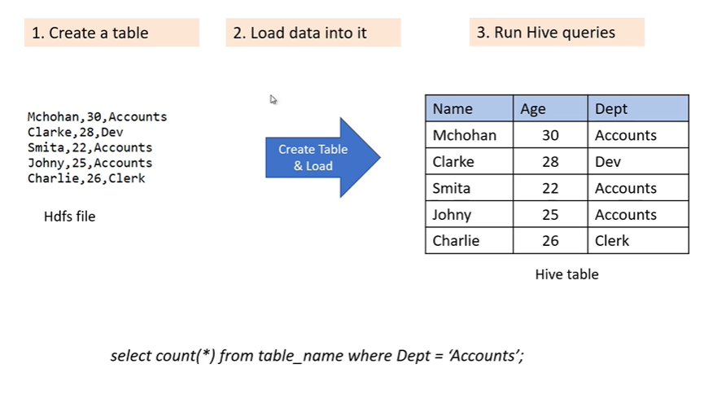

 Loading the data not at all means that I would be moving this data to Hive.

Hive is not a database, so we are not storing any data in Hive. Then what does this loading means?

Loading here means that, I'm mapping the schema of Hive table to this file in HDFS. After loading, Hive will see this HDFS file as a table of three columns, and this much data in it. After loading, Hive will see this file in a tabular way, and there is no such movement of data.

HIVE ARCHITECTURE:  
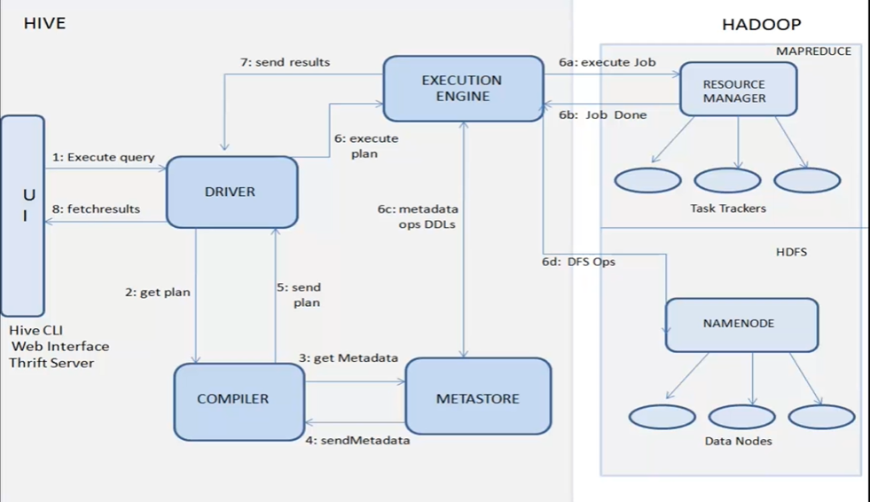

Suppose I have this query, "(SELECT MAX (price) AS (maximum price) FROM table_1".

Let's fit this query into Hive architecture.

This query is first being put by the user through user interface.

Then comes our driver. It will fetch the required APIs for the query, and then will convert this query into MapReduce program with the help of compiler.

Then the compiler component comes. It will do semantic analytics of the program,

and finally creates an execution plan for the program. While creating the execution plan, it has to get help of metastore, because metastore is the component which contains the structural information of table_1.

Metastore will tell compiler that table_1 contains these many columns,

and also that column "price" has which datatype.These all informations will be used by compiler to create the execution plan.

Then this execution plan will be provided to execution engine. Execution engine will interact with NameNode and resource manager of Hadoop framework to look for table_1 in HDFS and tell them to perform the task of execution plan i.e. to fetch the maximum price in price column.

Once the job is completed by Hadoop, it reverts back with the results which are finally displayed to the user in user interface.

Hive uses built-in Derby SQL server as metastore, but in real-time projects we don't use Derby because it provides single process storage. Means, while using Derby, we can't run two simultaneous instances of Hive CLI.

In real-time environment, we use MySQL or any other strong database as our metastore, which allows multiple simultaneous instances of Hive CLI.

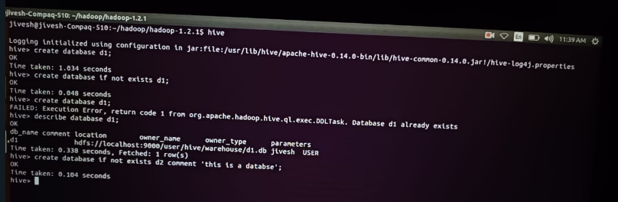

Create database

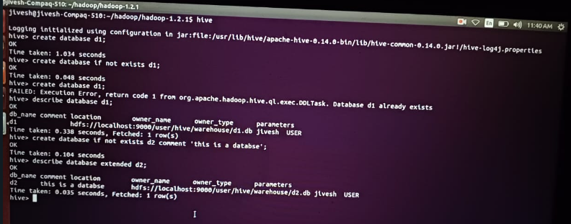

Extended

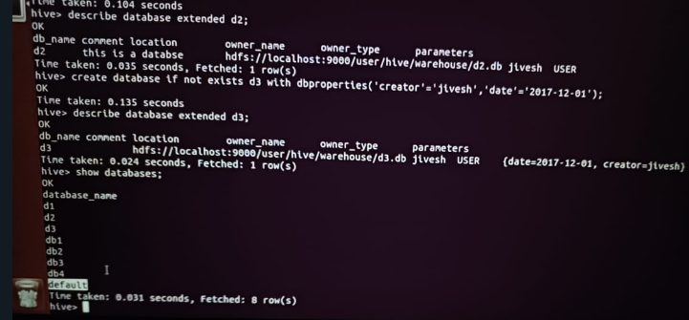

Show databases/Default database

Suppose, we are not mentioning any database while creating our table, the table will be stored in default sub-directory. And otherwise, in these databases.

Now if we want some tables to get data under a particular database, then we have use command. "Use D2". After "Use D2" command, now if I create any table,

that table will get created in D2 database, as now Hive is using D2 database to store everything.



We can create a table with location clause. By default, Hive will store the data mentioned in this path variable, "hive.metastore.warehouse.dir". So it gives us "user/hive/warehouse". But if we want to store our table in some other location, then we have to explicitly mention that path during the table creation.

So if I'm creating a new table, table_3, this is the query for table_3,

and here I'm mentioning that explicit location. The location is of HDFS, I'm giving "user/Jeevesh/table_3"

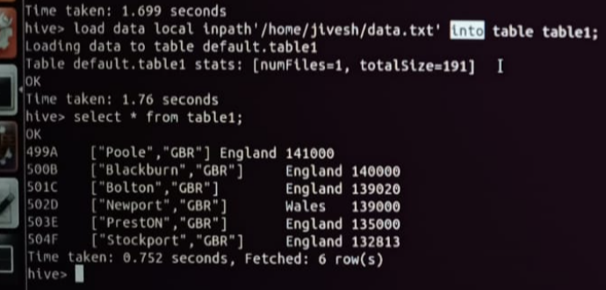

I have used the local keyword here, because my input file is present in local file system and not in HDFS. My input file is here, data.txt. If this file would have been present in HDFS, then we have to omit this local keyword and write "load data inpath", and then HDFS path to the file.

Into vs overwrite

Into is used to append the data.

It means if table_1 priorly has some data in it, then into will append the data to the previous data. But overwrite means, if table_1 already has data, then first clear the data of table_1, and then load new data in it.

Sorting-

For sorting, we will learn 4 clauses;

* order by
* sort by
* distribute by
* cluster by

**Order by** command is used for full sorting of our data. It guarantees total ordering of our data, and for this it has to be passed through a single reducer.

Use of Limit Clause in order by-

But there are some limitations of order by clause. In strict mode, the order by clause has to be followed by limit clause.

Limit clause is mandatory because, since we're passing the data to one reducer, and you know in production we have very large datasets, single reducer can take very long time to finish,

**Sort by** also does sorting but within a reducer.

Let's understand it like this. First of all, we agree that it is possible that MapReduce can use more than one reducer, as it is obvious in real time environment where our data set is large. So more than one number of reducers will be used in a job.

Now sort by will do the sorting within a reducer and not amongst the reducers.

That is why sort by clause does not guarantees the full sorting of data.

Hive uses **distribute by** clause to distribute the key-value pairs amongst the

reducers. We can say, distribute by clause decides which keys will go to which reducer.

It ensures that all the rows with same distribute by column value will go to the

same reducer.  distribute by does not do any kind of sorting, it simply distributes the column values amongst the reducer.

To do sorting, we have to combine distribute clause with the sort by clause. However, this also does not do complete sorting

**Cluster by** command is nothing but a short form of distribute by sort by command.

Instead of typing "distribute by sort by", you can use "cluster by". Logic-wise,

nothing different.

Lec 16 Date and Mathematical Functions

Date functions include

UNIX_TIMESTAMP,

So this function returns the number of seconds between the specified date in the

argument, and the Unix time epoch.

This Unix time epoch is a set value by Unix i.e. 1970-01-01,

and time is 00:00 hours.

FROM_UNIXTIME,

This command will return the date from seconds.

See, it has returned the date,

and that date it is calculating from 0 seconds to the time epoch.

TO_DATE function.

It will accept a string date as an argument, and it'll return the date portion of it.

(See lec for more functions)

**Mathematical Functions**

CEIL function will return the smallest integer, greater than number that we're passing into our argument.

FLOOR will return the greatest number, smaller than the argument passed.

ROUND will round off our decimal number. This is a decimal number. And this the argument up to which number of digits we want our decimal to be rounded off.

rand() -if we want to generate some random number.

**String Functions**

<https://sparkbyexamples.com/apache-hive/hive-built-in-string-functions-with-examples/>

String functions will contain CONCAT, LENGTH, LOWER.

CONCAT function.

Concatting will take three arguments.

I'm concatting the first column, and this is my delimiter by which I'm concatting these two columns. Then I'm taking the third column.

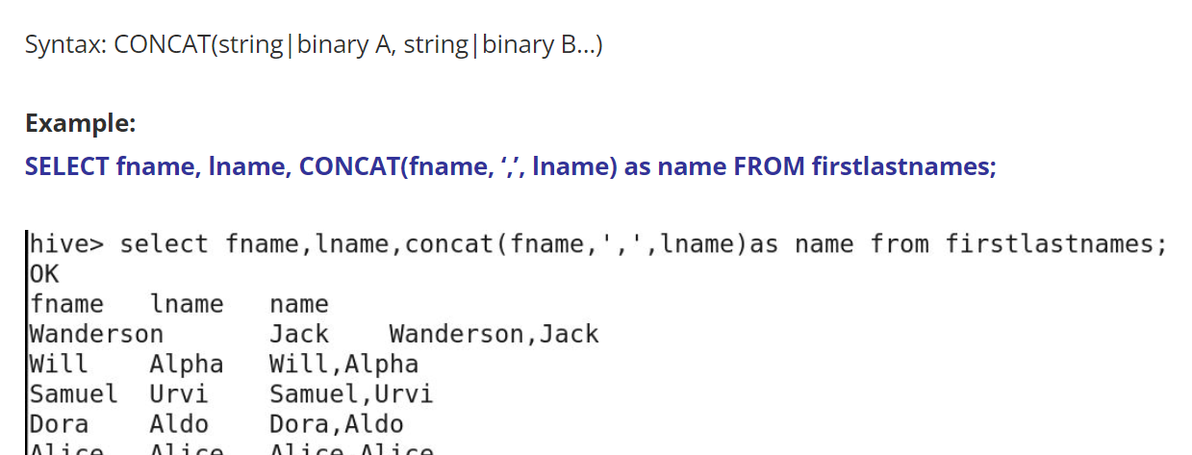

LPAD

This is the total number of characters we want in the string, including the padded characters. Pads the characters to the left side

This is the character which is to be padded in our string.

TRIM function will trim the spaces inside a string.

TRIM function is also of two types. One is LTRIM and other is RTRIM.

REPEAT function.

We have to give two arguments in it. One is the column,

and one is the number of times the data needs to be repeated.

REVERSE, as the name suggests, will reverse

the string.

Split function- Split function will split the string on a basis of a delimiter or any special

character that we provide in the argument.

Substring is used to take out a part from our base string. Hive has 1 based indexing

Suppose if I'm passing 3 over here, now our substring will contain total of 3 characters starting from 4th index. This was started from 4th. This is 1st, space is 2nd, and I is the 3rd.

Instring will return the position of a particular string or any character that

we have passed in the argument.

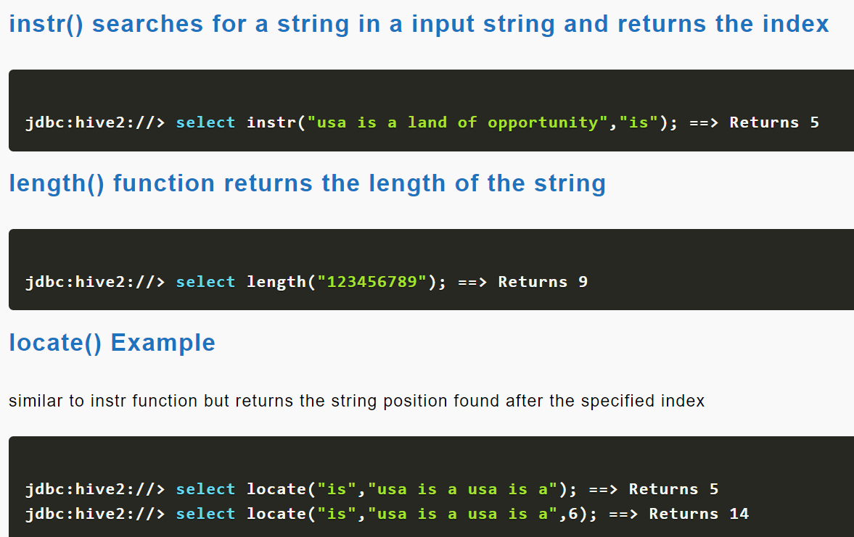

Conditional Statements

<https://sparkbyexamples.com/apache-hive/hive-conditional-functions-with-examples/>

IF Statement

Now I will use IF statement on it. "SELECT IF".

This is the condition we are putting over here, "column_3= "England"

". If column_3 is England, if this condition is met,

then it will select from column_1. If this condition is not met,

then it'll select column_4.

CASE Statement

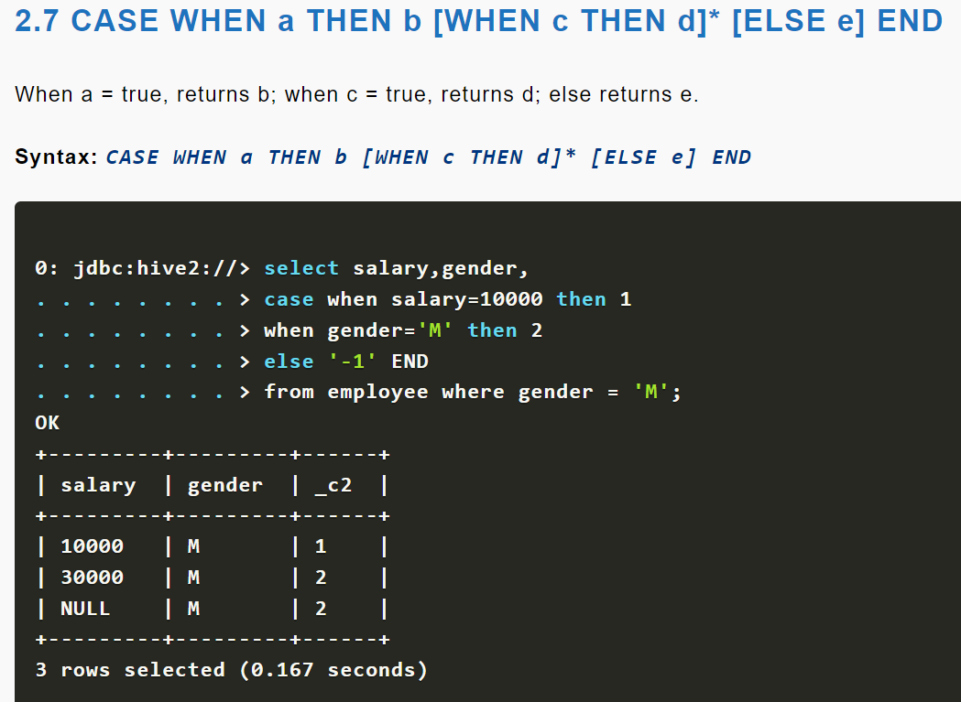

IS NULL is a Boolean function. It means it will return us true or false.

Now in this query, if the column_1 is null, it will return us true. If the column_1 is not null, it will return us false.

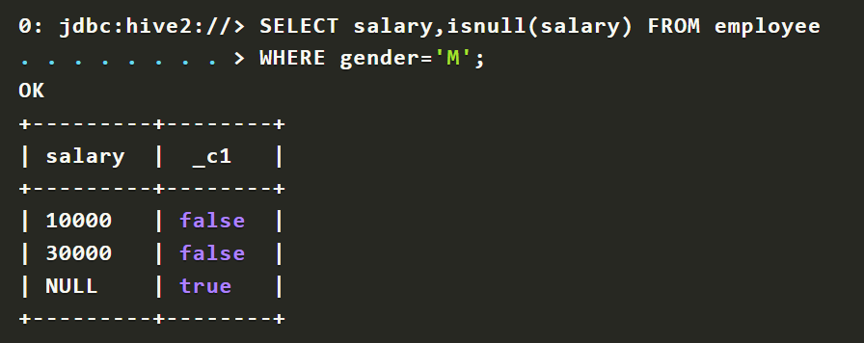

IS NOT NULL.

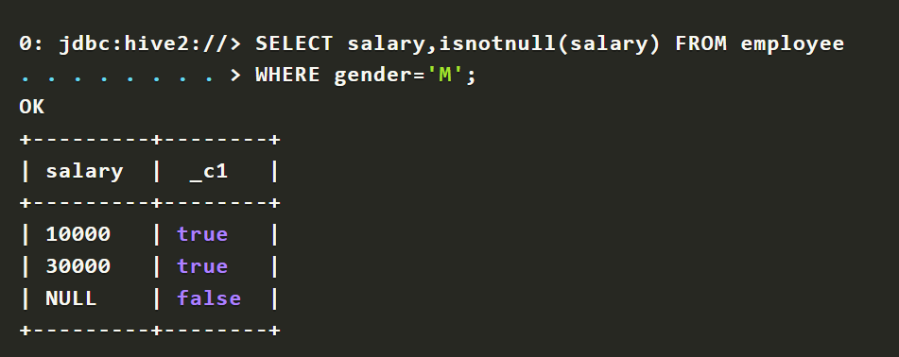

COALESCE function will select the first non-null value from the multiple fields.

Like here in this table, we have three columns,

and each column can contain null value or some date value.

Now we have to select only non-null value from these three fields.

So we'll select this query. "SELECT COALESCE".

NVL same function like COALESCE, but the difference is,

it has only two arguments in it.

So I'm simply explaining you in this example. We have used NV: function in here.

If the supplier description is null, then it will select supplier name.

If it is not null, then this column will be selected.

EXPLODE FUNCTION

Explode function takes an array as an input, and results the elements of that array as separate rows.

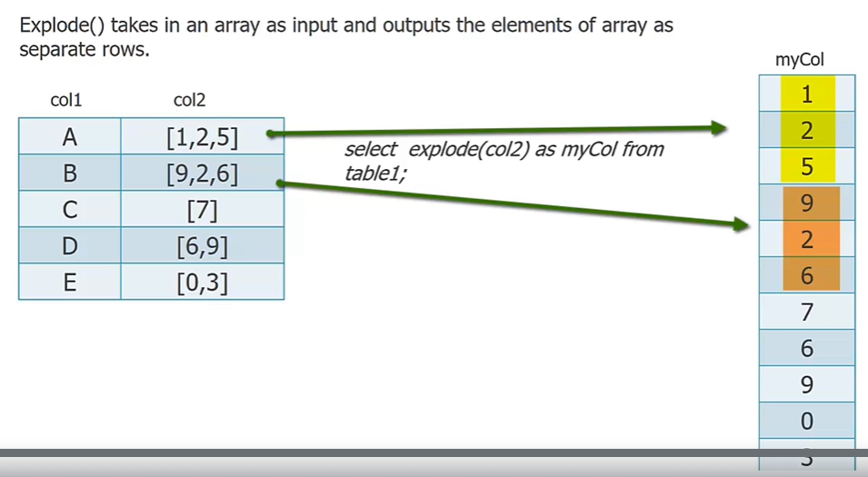

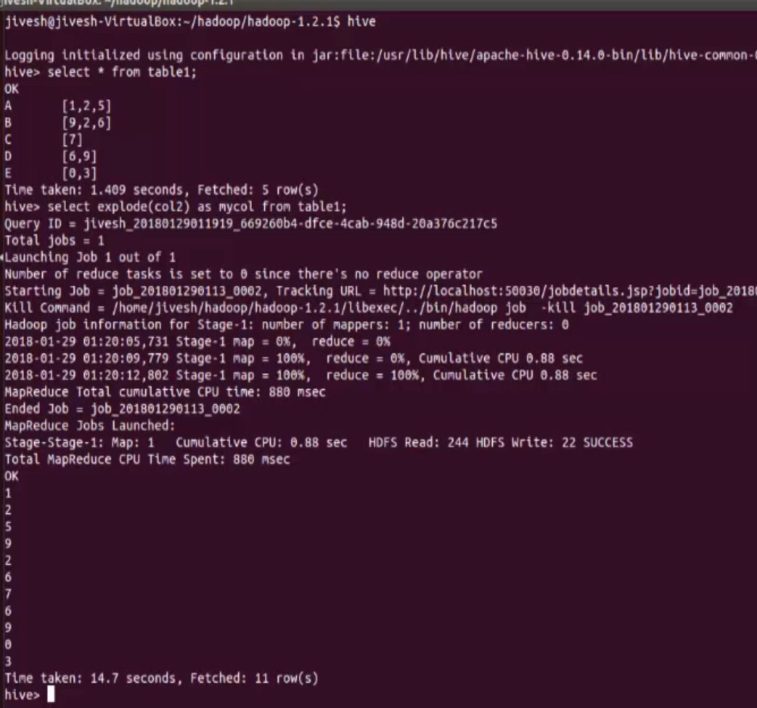

The limitation of explode function was that, we can select only the column to be exploded in our select statement, we cannot select other columns of table along with the exploded column.

LATERAL VIEW-

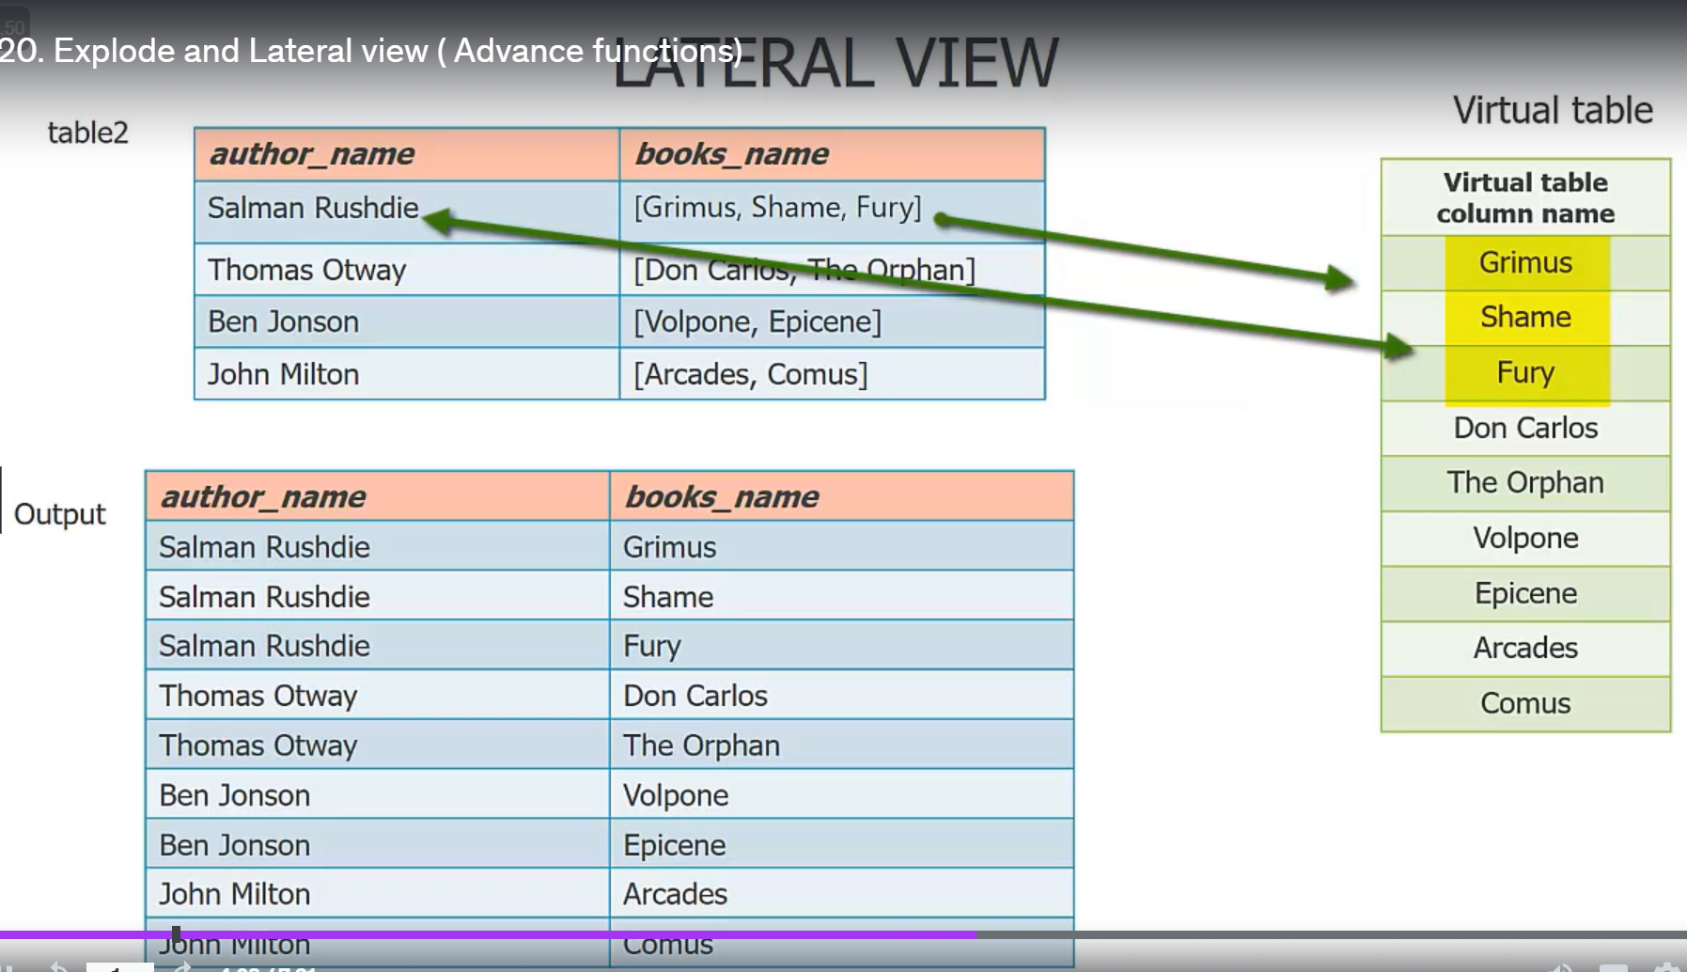

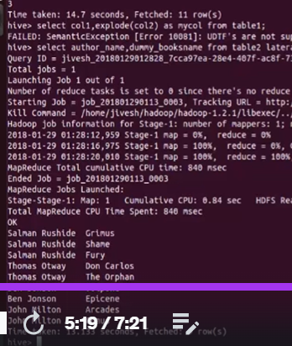

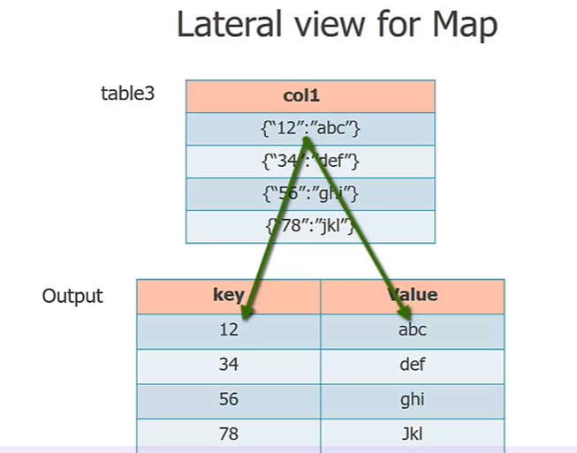

One more use of lateral view is that, it is used to take out the keys and values in separate columns from a map datatype.

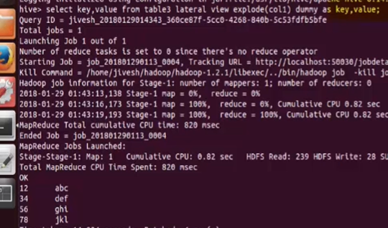

RLIKE

RLIKE is a shorthand abbreviation for right like.

RLIKE is a special function in Hive, where if any sub-string of A matches with B, then it evaluates to true.

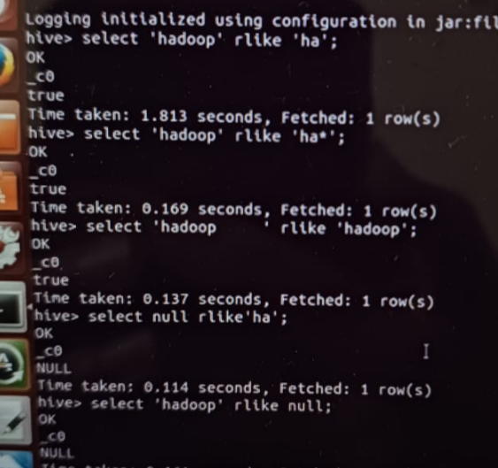

RLIKE will come handy when string has some spaces. Generally,

if a string contains spaces,

we firstly trim those spaces by using TRIM command and then matches the string.

But RLIKE function doesn't need any trimming.

Rank,dense rank and row number

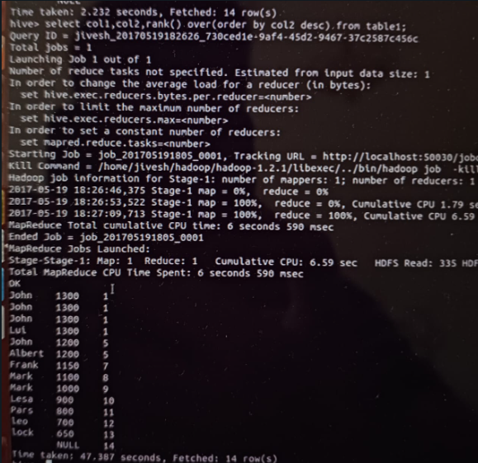

Rank function

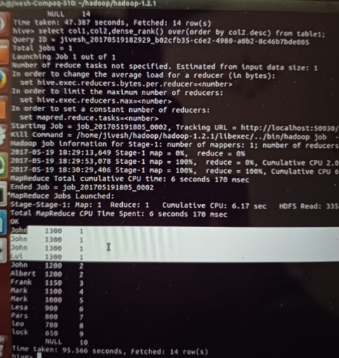

Dense rank

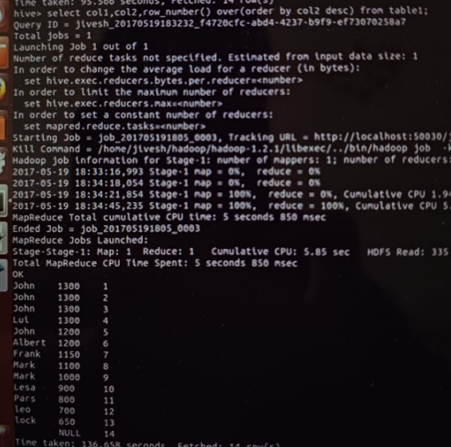

row_number()

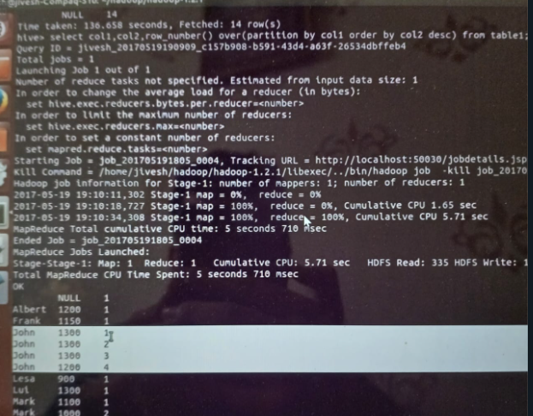

Row number with partition

Partitioning

Partitioning and bucketing, both are ways of organizing table data into parts based on partitioning key

Hive unnecessarily scan other departments when it has to fetch only accounts department. So why not we, at pre-hand create a separate directory for accounts department, and save only accounts department data in it. And similarly, more directories can be made for other departments.

So basically we are partitioning the data on department basis.

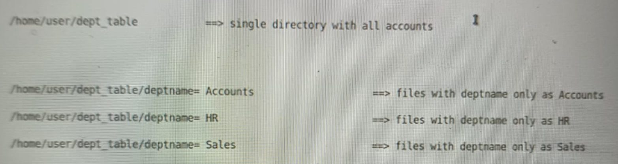

After partitioning, from now on, whenever a select query is fired with any department name in its "where" clause, then Hive will directly go to that department directory and won't go to others.

STATIC PARTITION-

Non partitioned table

create table if not exists dept (col1 int,col2 string,col3 string,col4 int) row format delimited fields terminated by',' lines terminated

by'\n' stored as textfile;

STATIC PARTITION

Partitioned table

create table if not exists part_dept (deptno int,empname string,sal int) partitioned by (deptname string) row format delimited fields

terminated by',' lines terminated by'\n'stored as textfile;

//Whatever column we use for partitioning, we do not mention it in the select statement

Static partitioning Load

//creating a directory named HR and selecting only HR data and loading that

insert into table part_dept partition (deptname = 'HR') select col1,col3,col4 from dept where col2 = 'HR';

load data local inpath'/home/jivesh/act'into table part_tab partition( deptname ='XZ');

======================================================================

create table if not exists part_dept1 (deptno int,empname string,sal int) partitioned by (deptname string)

row format delimited fields terminated by',' lines terminated by'\n'stored as textfile;

Dynamic partitioning Load

insert into table part_dept1 partition (deptname) select col1,col3,col4,col2 from dept;

So in static partitioning, we saw that there was manual loading of data.

But what if you want Hive to automatically create partitions based on partition

column value? This is what we call as dynamic partitioning.

Instead of user providing partition names and selecting the data from source,

Hive does it all by itself.

Which partitioning type to use and when?

Talking about static partition, since it requires the knowledge of data in pre-hand,

that is why I would say we will use it where the data is known well in advance

to us. But again, as we saw static partitioning requires a lot of manual effort; we have to write a separate query to load each partition, so it is advisable to use static partitioning where data is not very unique, which eventually will result in less number of partitions.

Opposite to that, dynamic partitioning is suitable when data is unknown to us or it has more unique values in partitioning column. But remember, that static partitioning is faster than dynamic, as in the former, we provide everything at pre-hand to Hive so there would be less comparisons. But in dynamic, Hive by itself has to do all the comparisons and then load the data into appropriate partitions, thus slower.

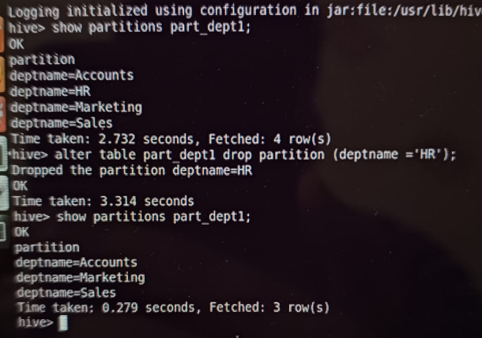

Show and drop partitions

Partitioning vs Bucketing

Do you expect to have a relatively low number of distinct values in a column you will be using a lot in filters, especially when there should be a roughly similar number of rows for each value? Partitioning would be the best choice. If, instead, there will be a lot of distinct values which might not be as evenly distributed, consider bucketing instead.

If hive.exec.dynamic.partition.mode is set to strict, then you need to do at least one static partition. In non-strict mode, all partitions are allowed to be dynamic.

MSCK repair command from lecture

Bucketing

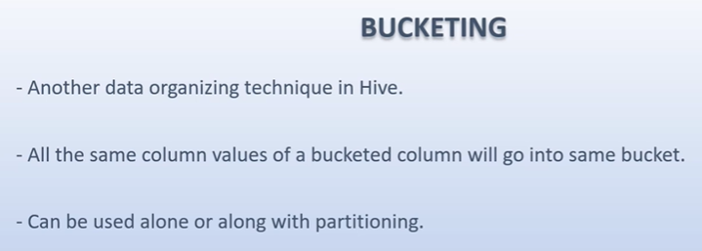

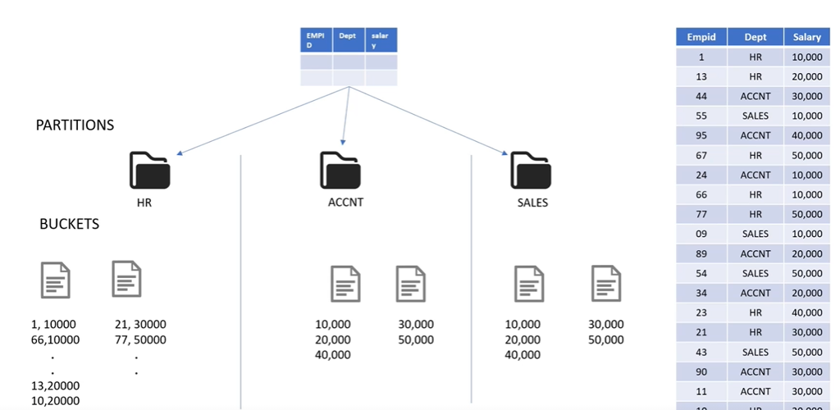

Bucket is physically a file We can explicitly set the number of buckets during table creation Bucketing alone can be more effective sometimes

Bucketed Map joins are the fastest joins

Condition:Both joining tables should be bucketed on the same column as of joining column and both tables should have equal no. of buckets.

Tablesampling

table sampling means a sample of data from a table in a fashion manner.

Few records of data out of thousands of records.

Now you would ask that this sample, even a limit operator can take? Right?

"SELECT * From table_name", limit 10, 20, 30, whatever sample number you want?

This question is logical,

but there is a difference between limit and table sampling on how they take out

the data. Actually, limit operator does not guarantee a fashion sample.

Non-fashioned as in,

it can take out the data from only one partition and one bucket.

That data would only be limited to that partition, that bucket,

and it won't be a distributed dataset. Obviously,

that cannot be considered as a sample. But table sampling, what it will do is,

it will collect the data in a distributed manner from a number of buckets.

Let me show you the difference practically. So suppose,

I'm taking the sample of data using limit operator first.

I'm using the previous bucketed table.

"SELECT * FROM key_pt

LIMIT 15".

So this limit operator is giving us 10 rows from first bucket only. Locations,

Delhi, Chennai, Hyderabad, Washington, Pune,

they were present in first bucket of our table.

So this dataset is obviously not uniformly distributed.

Let us now perform table sampling on this.

We had made 4 buckets. Now here what table sample clause is doing,

it is dividing your 4 buckets into groups of 2 buckets each,

and then selecting first bucket of every group.

Tablesampling should generally be done on bucketed column:

table sampling can be done on any column, even on a non-bucketed column,

but in that case,

table sample clause will scan the entire table and then fetch the sample.

And you know that scanning entire table takes time,

so it's better to do table sampling on bucketed column,

 sampling can also be done using some other parameters,

like percentage or number of rows.

No_drop and Offline command

As the name is suggesting,

no drop command will prevent a table or partition from being accidentally

dropped. In our projects,

we have some critical tables that are not meant to be dropped in any case.

So as a safety measure, we can enable this no drop facility to our table.

Can also disable this feature

Can also limit the usage to a particular partition and not the entire table

Offline command:

Now the second guard is offline. It prevents our data from being queried.

JOINS

create table if not exists emp_tab (col1 int,col2 string,col3 string,col4 int,col5 int,col6 int,col7 string) row format delimited fields terminated by',' lines terminated by '\n' stored as textfile;

create table if not exists dept_tab (col1 int,col2 string,col3 string,col4 string) row format delimited fields terminated by',' lines terminated by '\n' stored as textfile;

Inner Join 2 tables

select emp_tab.col1,emp_tab.col2,emp_tab.col3,dept_tab.col1,dept_tab.col2,dept_tab.col3 from emp_tab join dept_tab on (emp_tab.col6 = dept_tab.col1);

(HIVE SUPPORTS ONLY EQUAL TO OPERATOR IN JOIN

LEFT OUTER JOIN

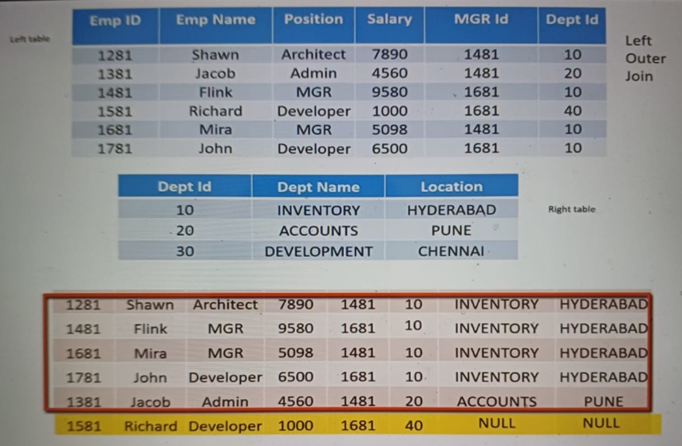

(Takes all the data from the left table.Here we are joining using depart id. Since id 40 is present only in left table, we get NULL in the right part of it.)

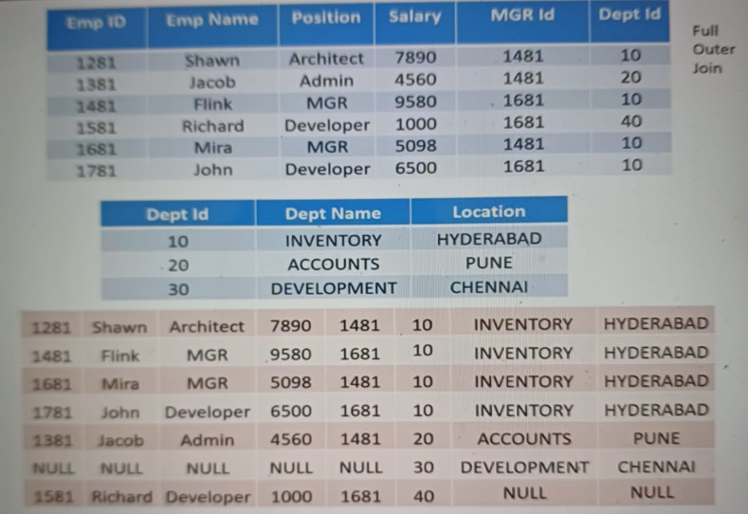

FULL OUTER JOIN

Join 3 tables

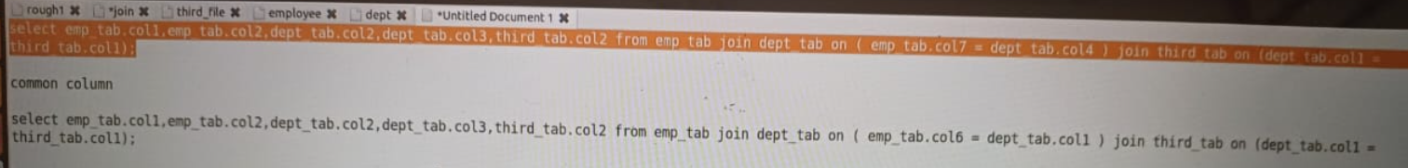

select emp_tab.col1,emp_tab.col2,dept_tab.col2,dept_tab.col3,third_tab.col2 from emp_tab join dept_tab on ( emp_tab.col7 = dept_tab.col4 ) join third_tab on (dept_tab.col1 = third_tab.col1);

(THIS IS NOT RECOMMENDED)

Optimizing Joins

By default,

the last table of join is streamed and others are buffered in the memory.

So this means, if I'm talking about this query;

this previous to previous query,

where we did the join on common column department ID, then in this case,

employee table and department table will be buffered in memory,

while the last table in query i.e. the third table,

will be streamed through the reducers. And in the other query,

where two different joining conditions were used, in that scenario,

2 jobs were there. So in first job,

employee table is buffered and department will be streamed.

Then in the second job,

the result of first job will be buffered and third table will be streamed.

Now considering this rule that states, that "by default,

last table of join is streamed", it is advisory that out of the two tables,

whichever table is large,

large as in which is big enough as compared to our buffer memory,

keep that table at last in the joining query

(See lec for explicitly setting a atbvle as streamtable)

MAP JOIN

in any MapReduce job,

the reduce step is considered to be the slowest as it includes shuffling off

data from various mappers to a reducer over the network. If this is the case,

then why don't we perform a join in mapper side only.

If our data is small enough to fit inside a mapper's memory,

then there is no need to go to a reducer step.

The join can be performed on mapper side itself. Right? Well yes,

perfectly true, and this is what this lecture is all about.

How to make Hive perform a join on mapper side only when we know that our data

is small, at least one table is small,

and it can easily fit into mapper memory and can be cached locally.

And these type of joins are called map joins.

Two ways to perform map join:

1.)Explicity mentioning in the query on which table we should do map join

2.)Setting a few properties to allow Hive to perform map join.

By default this property is false,

make it to true. "Set hive.auto.convert.join" to true.

Second property is file size property. "Set hive.mapJoin.smallTable.fileSize".

It's default value is 25 MB.

It means that any table which is less than 25 MB will be considered as small

table by Hive, and Hive can cache that table in mapper's local memory,

and eventually perform a map join. With the help of these two properties,

Hive will itself decide to perform map join when one of the table is less than

25 MB in size

Limitations

map joins has some limitations also.

First major restriction is that we cannot perform full-outer map joints.

However, we can perform left-outer map join and right-outer map join,

but full-outer map join is not possible.

Optimisations in Join:

<https://engineering.fb.com/2010/12/15/core-data/join-optimization-in-apache-hive/>

Optimisations in HIVE-

<https://medium.com/swlh/hive-optimization-quick-refresher-5e596654bc1d>

VIEWS IN HIVE

Views are virtual tables which are created as a result of a hive query on some

table. I'm saying virtual tables, as they do not actually contain the data.

Basically in Hive,

view is kind of a searchable object in a database which itself does not have any

data but can be populated by the results of a query.

Here are some few properties of view. First is certain,

that hive views do not contain any data of its own,

but they are merely the results of any hive query on a table.

Second is that, all type of DML operations can be performed on a view,

same like table's DML operations.

Views can be created by selecting any number of rows and columns from its base

table or tables. Tables I am saying,

because views can also reflect the results of join of N number of tables.

Once created, views become independent of it's base table schema. It means,

after you created a view on a table with a schema,

that schema of view gets frozen and it won't change if you change its base table

schema. If you have to change view schema, you have to use alter views command.

Also, vice versa is true.

Changing the view schema won't change our table schema. Views are read-only.

Any drop or write queries on views will not affect our base table.

Next, dropping the base table will make the view on that table ineffective.

This makes sense because view does not have its own data and it is reflecting

the queried data of its base table only. So once the base table is dropped,

so our view would be like a kite without strings.

So any query fired on that view will fail.

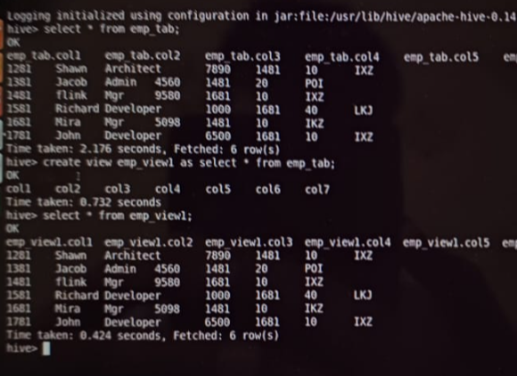

Creating a view

Alter,rename,drop,….all commands which can be used on a table can be used on a view

Advantages of View

his is one major advantage,

and I can say the motivation behind the invent of views,

that views can be used to hide the underlying table columns from some users.

Second advantage is that, by creating views,

we are protecting our base tables data from being accidentally dropped or

altered. Views are read-only and can only show the table data,

they cannot alter or drop it.

One more advantage that can be considered is that,

views lets us create a shorthand abbreviation for a more complicated query,

like a join query.

Indexing in HIVE

An index acts as a reference to records.

Index allows us to speed up the searching of data,

as instead of searching all the records,

we can refer to the index to search for a particular record.

Indexes maintain the reference of records. Without an index,

queries having WHERE clause, like WHERE column_1=100,

load the entire table or partition,

and processes all the rows searching for column_1=100. But

if an index is present for column_1,

then only that portion of data will be searched.

Now the question arises, the partition also does the same thing.

But here's one difference in both,

that partition provides segregation of the data at the HDFS level,

creating sub-directories for each partition.

But indexing is done at table level.

Indexes are used to speed up the search of data within the tables.

if we use indexing on that column,

the query checks the index first,

and then goes to a particular column and performs the operation.

This saves our time and resources.

With deferred rebuild-

This statement should be present in the created index because we may have to

alter the index in later stages using alter statement.

Let's suppose,

we have created an index on a table with some initial content in it. Later on,

the data is changed inside the base table,

but our index table is unaware of it.

So to make the index table up to date,

we have to rebuild it by using alter command.

while creating an index with "differed rebuild" clause,

then the newly created index is initially empty,

regardless of whether that table contains any data or not.

The alter index is used to build the index structure for our table.

Like in our case also,

our index table was empty till first.

Only after altering the table

with rebuild command, our index table gets populated.

Advantages and Disadvantages of Indexing-

First of all when to use. We can use indexing whenever data set is very large, that is,

the data set is in gigabytes or more.

Secondly, if speed is concerned in query execution; where latency matters.

Now third, indexing can be used where our query relies on frequent using of WHERE Clause in select statement.

Contrary to that,

we should not use indexing whenever data set is small,

because building index is itself time consuming,

building more number of indexes can also degrade the performance of our query.

Second,

we should not use indexing whenever data set is made up of almost unique rows,

because in that case,

there will be a lot of index IDs for each column value.

<https://hashnode.com/rix/64fc1415eaf8c3a6d4919e27?source=hn-widget>

<https://www.sparkcodehub.com/hive/indexing-in-hive?utm_source=hashnode&utm_medium=hashnode%20rix&utm_campaign=rix_chatbot_answer>

<https://www.educba.com/indexes-in-hive/?utm_source=hashnode&utm_medium=hashnode+rix&utm_campaign=rix_chatbot_answer>

UDF-

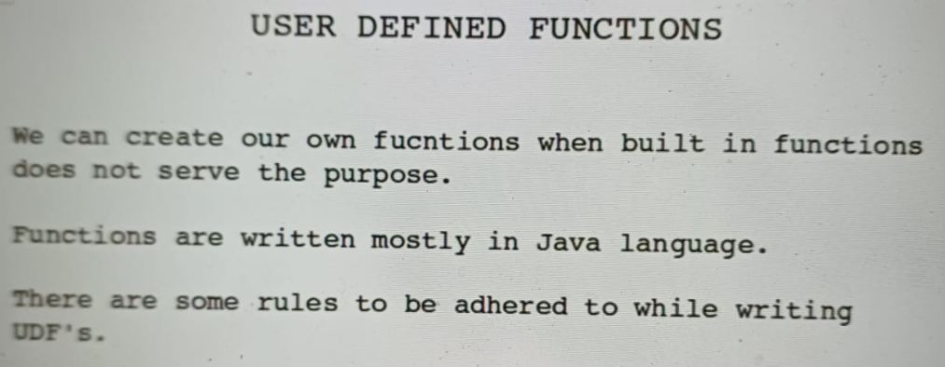

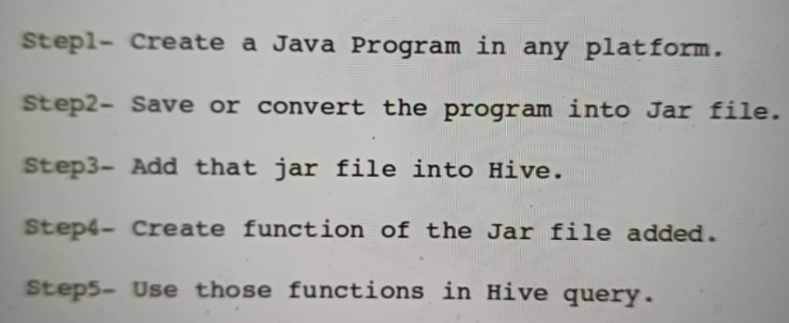

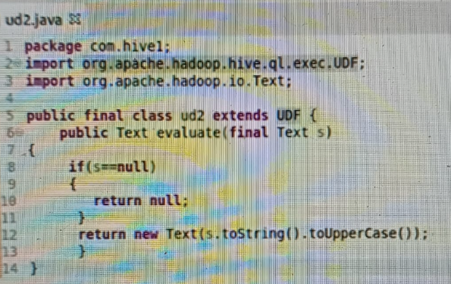

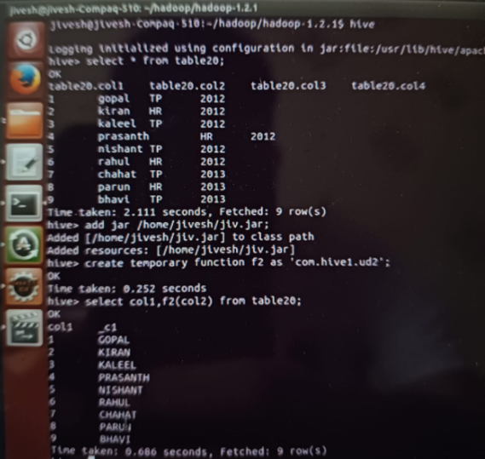

TABLE PROPERTIES

Active vs Passive properties

Passive table properties do nothing, they just tag a table, like,

we can give creator name, date of creation. While creating the table,

they are simply used for tagging purpose.

But active table properties are those in which it helps in data processing,

or which can be responsible for selecting a specific data from the table.

<https://medium.com/@tsaiprabhanj/hive-table-properties-configurations-d2900b3255fd>

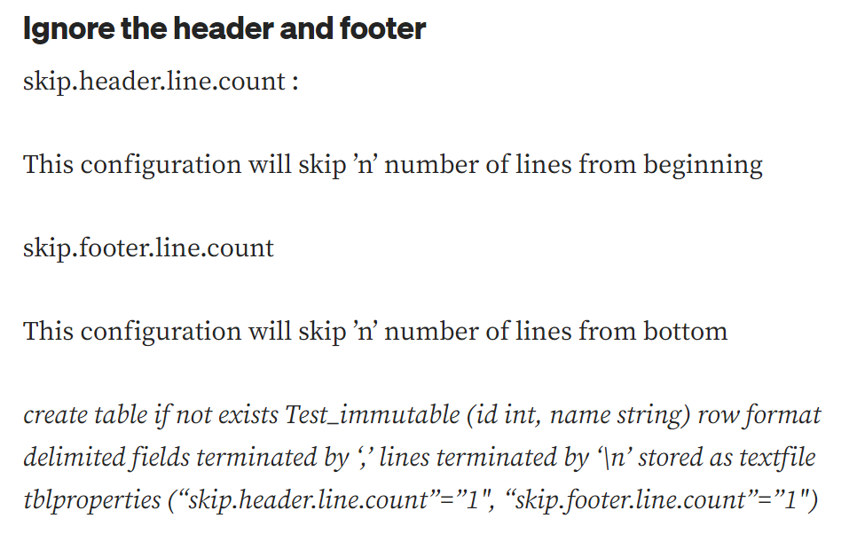

**Mutable and Immutable**

Hive provides an option to create mutable table and immutable table.

**Mutable Table**

All the tables by default are mutable. Mutable table allows appending the data when data already present in table.

**Immutable Table**

A Table can be created as immutable table, by setting its table property to True. By default this property is false.

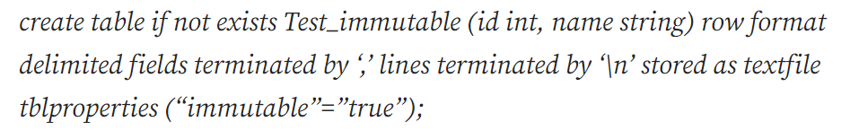

Immutable property allows us to load the data for the first time. After the first data insert, the successive insert into commands will fail resulting in only one set of data into table.

If we try to insert data into immutable table, the it will throws error saying,



Also insert overwrite works as it used to work on normal mutable tables. So there is no change in that.

Drop vs truncate

Drop table removes the metadata and the data for a table,

means both, the structure of table and the data inside the table is removed.

But this holds for internal table only,

as internal tables are completely managed by Hive. In external table also,

metadata and data is removed, but from only Hive table,

but the data will be still present in HDFS location.

As external table's data is completely managed by HDFS itself,

so only the linkage between the Hive and HDFS is removed.

Moving on to truncate. The difference between truncate and drop is,

truncate removes only the data from a table,

metadata or structure of the table will not be removed,

it will remain intact as it is.

# ****Purge****

Purge is a table property. If Purge is set to true, then in case of dropping/Truncating an internal table, the data won’t go to trash, it will be permanently gone. And in case of Insert overwrite table, the previous data won’t go to trash, it will be permanently deleted. This property works only for internal table.

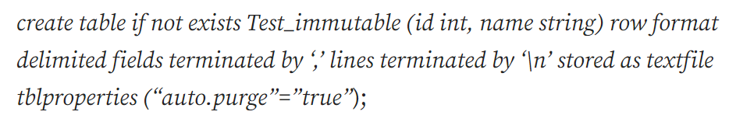

Null Format Property

**Because by default nothing is null between the delimiters.** Everything is data for Hive between the delimiters. **Hive won’t treat a missing value as NULL value.** It will be normal value for Hive, even if it is empty.

Now to capture this NULL values or to marks these empty values as null values, we have to mention a table property while creation of table.

Let’s create another table – We have used table property “serialization.null.format” is equals to “” (empty) as we want to replace empty fields with null. In case we want to replace spaces with null we would have to change the value(after equal to sign) while setting table property, so that it gets treated as null.

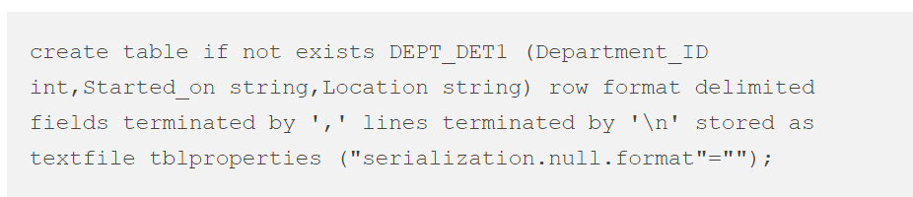

ACID Properties/Transaction Tables in Hive

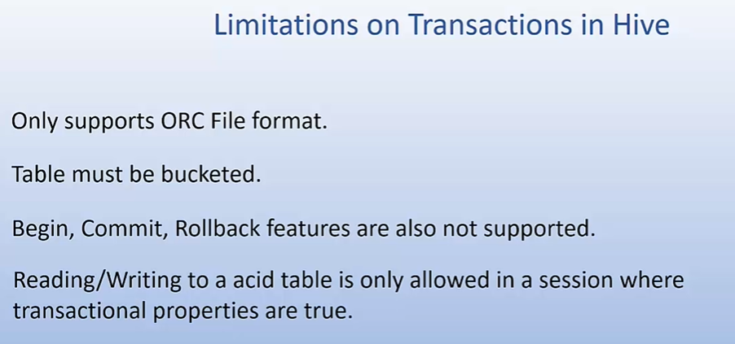

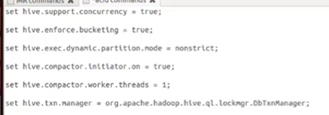

<https://www.sparkcodehub.com/hive/unleashing-transactional-tables-in-hive>

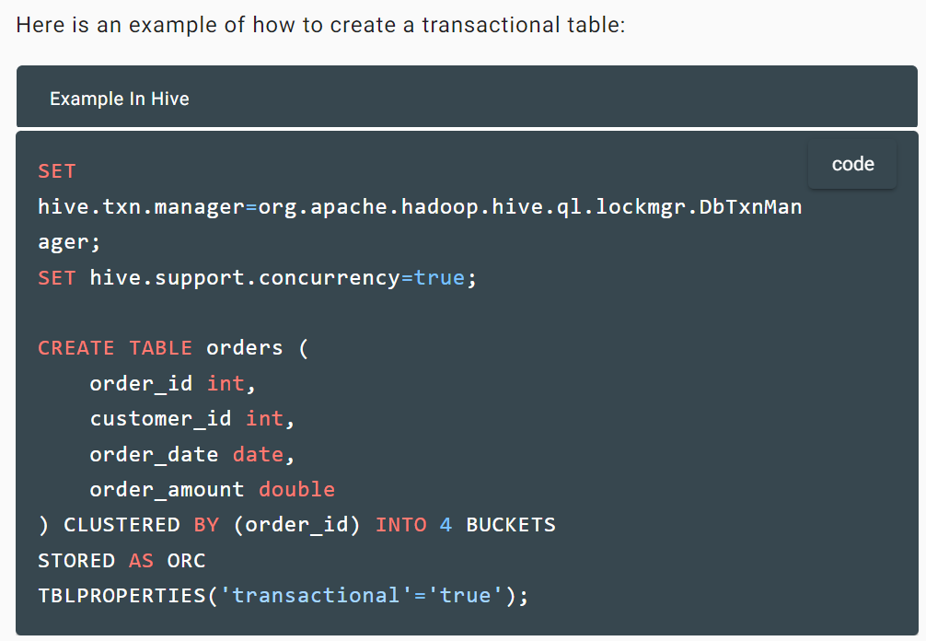

After setting this transactional property of this table to true,

our employee table has now become acid-enabled.

We can now perform insert, update, delete, operations on it.

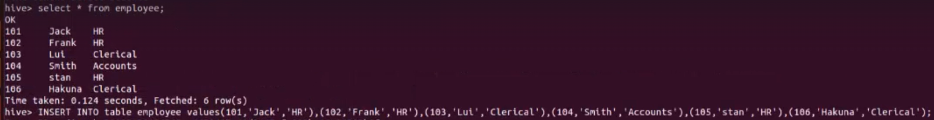

INSERT INTO

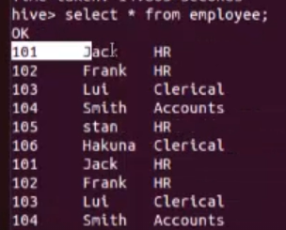

(Data has been inserted)

we cannot update the bucketed column in Hive. This can be considered as one more limitation in transactional features of Hive.

Some ORC properties in the lec

Hive Configuration Properties

<https://tsaiprabhanj.medium.com/hive-configuration-quick-reference-49b95565eb5a>

<https://cwiki.apache.org/confluence/display/Hive/Configuration+Properties>

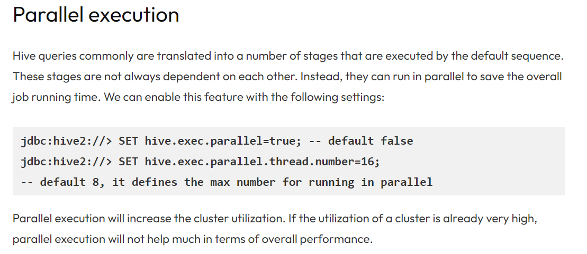

Can use hive from bash also

Basically, we have two options for this; option E and option F.

E is to execute hive queries and F is to execute hive scripts.

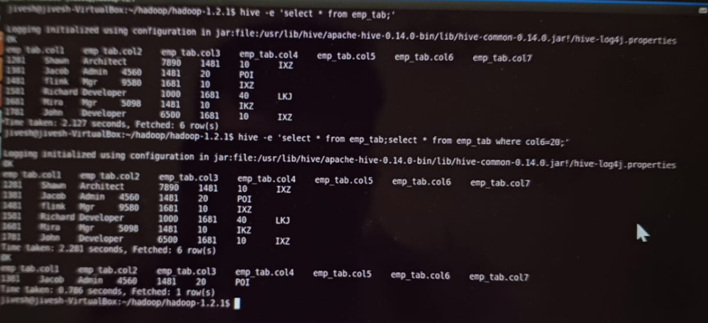

Running hive query using hive -e

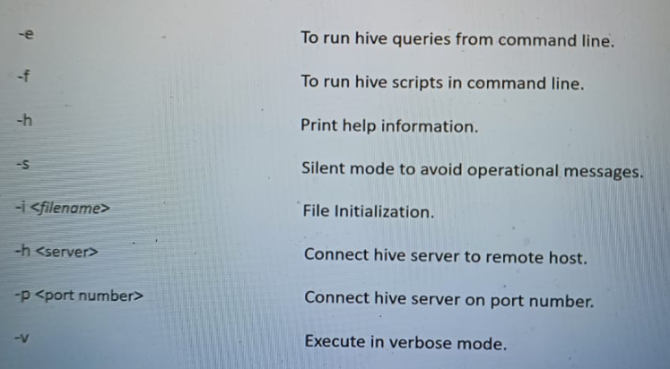

You can run both Hadoop and Unix commands from hive shell.

We will start with Unix commands.

A simple rule to run Unix commands in hive shell is to put an exclamation sign

before every Unix command.

Like pwd of Unix will become !pwd in Hive.

Interactive commands cannot be used in this manner. Also,

pipes don't work in hive shell. For example,

if you want to list all the files in Hadoop directory which starts with C,

you can easily put "ls -c*" in Unix.

But if you try to do the same in hive shell by putting "!",

!ls -c*",

it will show no such file or directory. Because in this case,

it is searching for a directory whose name is exactly "c*" and not that

directory which starts from C.

And since there is no directory which has "c*" name,

so returning no such file or directory.

Now let us see how to run HDFS commands in Hive. Starting with,

suppose, I want to list all the HDFS files, then write "dfs -ls"

HDFS Commands  
<https://www.youtube.com/watch?v=8vrUaMVG4po>

Variables in HIVE

Hive actually provides two types of variables, hiveconf and hivevar.

hivevar sets the value globally while hiveconf sets the

value locally.

By default, if you're setting variables without hivevar or hiveconf,

hiveconf variable will get set.

There is one provision in variables,

that we can pass the value of variable through other variable.

Suppose, we have a variable to which a value is given,

like we have hard coded the value to it, and now we create a new variable.

To this variable, we can assign the value as our previous variable.

But for that we have to set a property in Hive.

This is set "hive.variable.substitute".

File Types

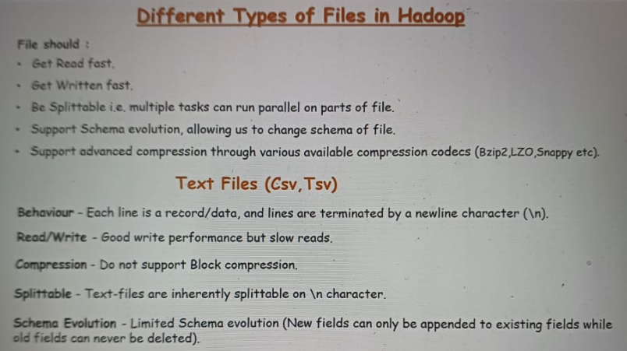

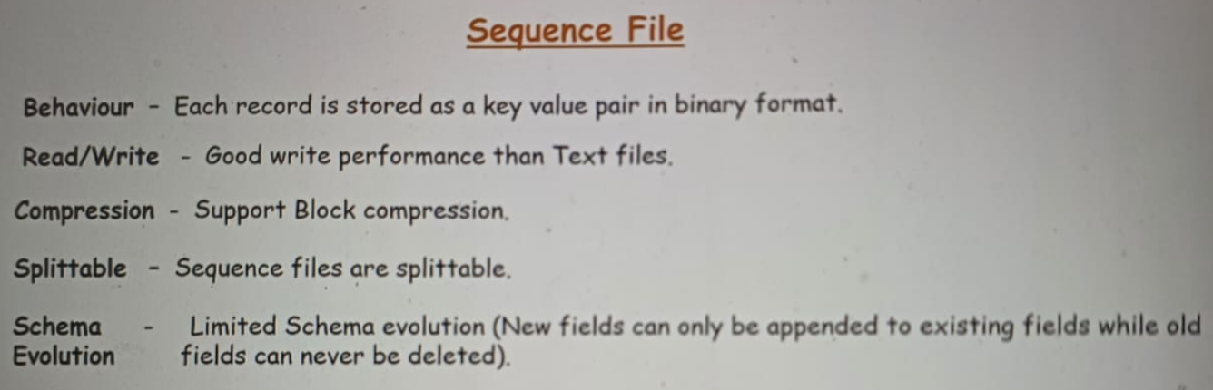

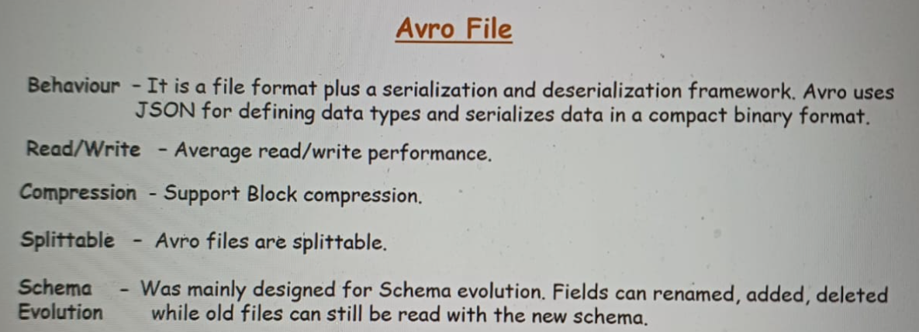

Columnar Files-

Optimised Read but slow on write performance

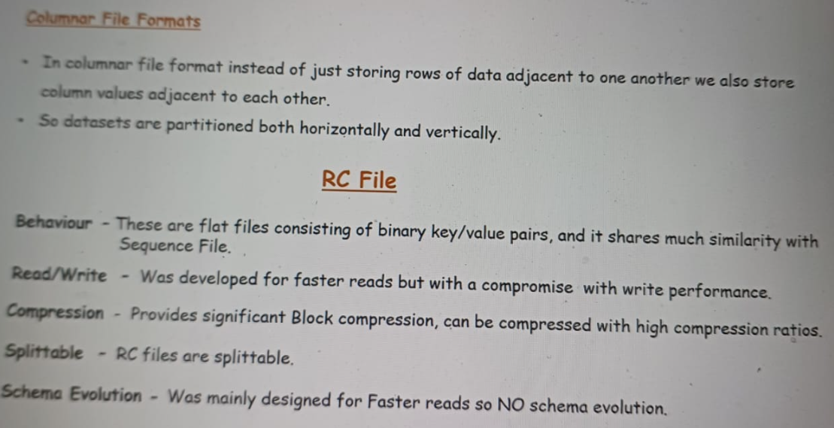

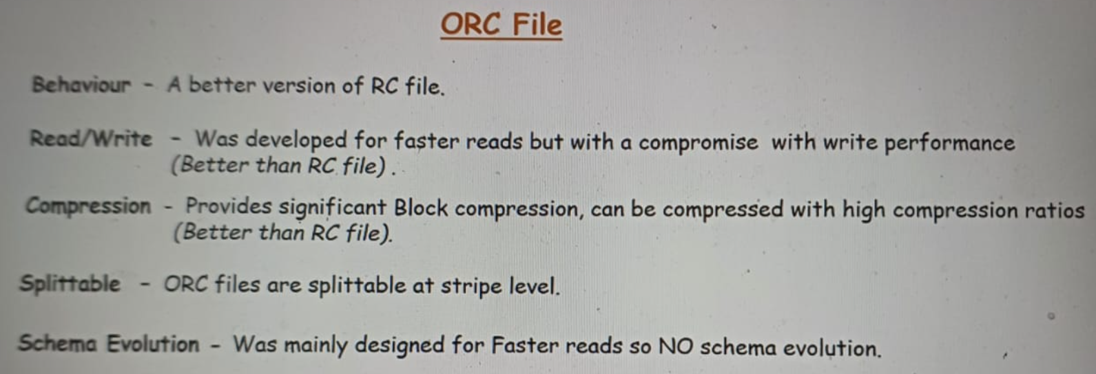

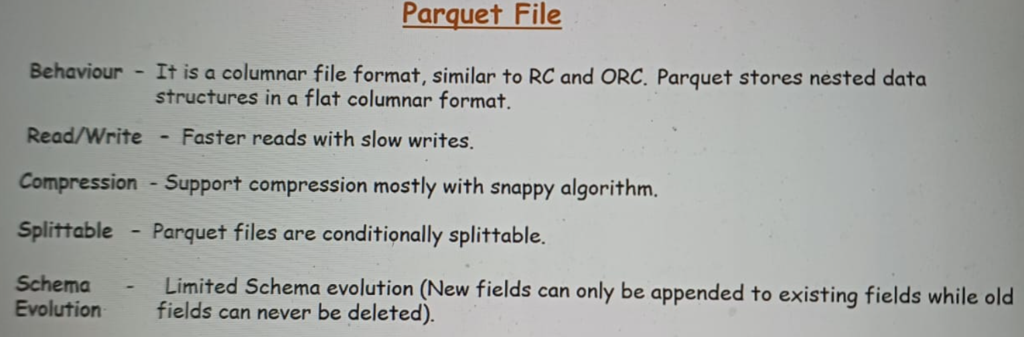

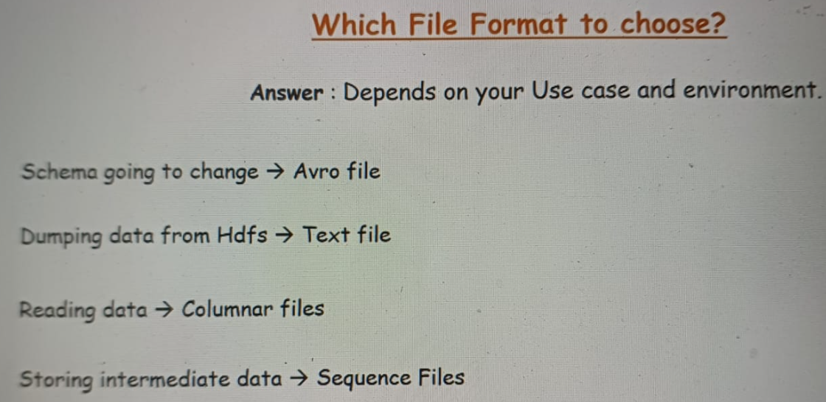

Modes in HIVE

<https://senthilnayagan.medium.com/hive-metastore-5b7a4edb09ec#:~:text=Embedded%20mode%20is%20the%20default,JVM%20as%20the%20Hive%20service>.

Hive Compression Techniques

<https://www.linkedin.com/pulse/hive-compression-codecs-prateek-kumar/>

<https://sharikrishna26.medium.com/compression-techniques-in-hive-f5929a57ad76>

<https://goraidebashree7.medium.com/hive-compression-codecs-with-example-24043bfd7a3a>

HiveRC file

It is a file that is executed when we launch the Hive shell.

Whenever we type Hive and press enter, this file gets executed in the backend. HiveRC File is an ideal place for adding Hive configurations or customizations

that we want to set on start of Hive shell. At anytime, we can set these configurations in our Hive session also, but they are limited to that session only. So if we set the property to display the headers of a table to true, then this property would be applicable for that session only. As soon as we type quit, this property will become false(default value)

The location of HiveRC File is hiveconf directory. So we'll go to this hiveconf directory,

cd $Hive_Home.

This is my hiveconf directory. I'll go inside it. Now inside this, I have to create a .HiveRC file. So I'll use VI editor. Now in this editor or in this file, we can set any settings. I'll set header command first. "Set hive.cli.print.header=true".

Archiving Files

Archiving means transferring the data to a less frequently used storage medium

so that frequently used data can be placed there. Mostly, we archive the old data since it is less used. Now the question arises, why we need archiving? The answer is,

we do archiving to reduce the load of name node, because for every file present in HDFS, there has to be an entry for it in the name node.This seems okay when the number of files that less, but when number reaches in millions then it directly affects the memory consumption in the name node.

Archive does not do space save in HDFS because we are putting files from

HDFS to HDFS only. We're not taking the files out of HDFS. We are just collecting those files into one. We are giving one address to the name node. So it reduces only the load of the name node, but it does not reduce the space in the HDFS.

TEZ Engine

Loading XML file

Download SerDe (derialisation deserialization from the internet and then load it.

Each tag in the XML file <book>, <author>….will act as a column in our hive table.

SCD/CDC

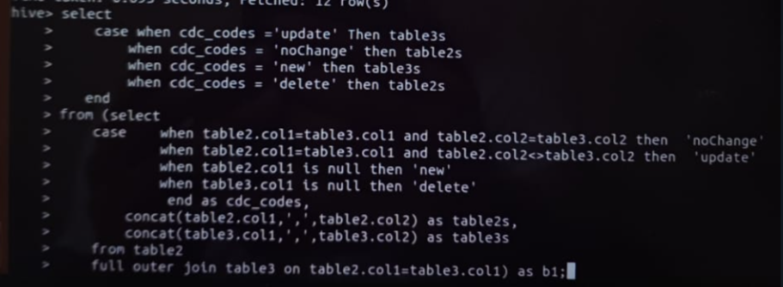

We have two tables, table2 is the original one and the table3 either has some records as same,updated,deleted or added. This query deals with that. (Implementation of SCD.)

Word count Example in Hive

Use the explode function,split the names by , delimeter. Then use count.